 **UNIVERSITY ADMIT ELIGIBILITY**



**PREDICTOR**

**(TEAM ID** **: PNT2022TMID36733)**

# A PROJECT REPORT

***Submitted by***

**MOHANDAS V (210219104025)**

**SUNILKUMAR S (210219104036)**

**PRAVEENKUMAR G (210219104027)**

**HARISH C (210219104012)**

**KARAN I (210219104019)**

**DINESH ASHIK J (210219104009)**

***In partial fulfillment for the award of the degree***

***of***

**BACHELOR OF ENGINEERING**

**IN**

**COMPUTER SCIENCE AND ENGINEERING**

**APOLLO ENGINEERING COLLEGE**

**ACKNOWLEDGEMENT**

We would like to express my sincere thanks to **Dr. R. MANOHARAN, M.E, Ph.D.,** Principal of our college for their constant support and encouragement towards completion of this project.

We would like to express our heartfelt thanks to **Mrs. S. RUKMANI DEVI,** Head of the department, project evaluator and Assistant Professor project mentor **Mrs. B.**

**JERINA.**

Further Thanks to IBM, Tamil Nadu state Govt, ICT academy & Anna university.

We would like to express my heartfelt thanks to the department staffs for their continuous support and encouragement.

**ABSTRACT** At the time of admission all the work is done by manually by ink and paper, that is very slow and much time and effort consuming. Students admission is one of the most important activities in education industry. A poor and slower admission system can mean fewer students being admitted into abroad universities because they don’t have proper source to do the process. This project aims for automated system, pre checking the inclusions of all required data and automatically listing each student based on their application. The data used by the system is stored by database that will be center of all information. This enables things to be simplified and considerably quick, making it easier. It supports the current process but centralized it and make it possible for abroad universities

**PROJECT REPORT FORMAT**

1. INTRODUCTION
   1. Project Overview
   2. Purpose
2. **LITERATURE SURVEY**
   1. Existing problem
   2. Reference
   3. Problem Statement Definition
3. **IDEATION & PROPOSED SOLUTION**
   1. Empathy Map Canvas
   2. Ideation & Brainstroming
   3. Proposed Solution
   4. Problem Solution fit
4. **REQUIREMENT ANALYSIS**
   1. Functional requirement
   2. Non-Functional requirement
5. **PROJECT PLANING & SCHEDULING**
   1. Data Flow Diagrams
   2. Solution & Technical Architecture
   3. User Stories
6. **PROJECT PLANING & SCHEDULING**
   1. Sprint Planning & Estimation
   2. Sprint Delivery Schedule
   3. Reports from JIRA
7. **CODING & SOLUTION (Explain the features added in the project along with code)**
   1. Feature 1
   2. Feature 2
   3. Database Schema(if Applicable)
8. **TESTING**
   1. Test Cases
   2. User Acceptance Testing
9. **RESULTS**
   1. Performance Metrics
10. **ADVANTAGE & DISADVANATAGES**
11. **CONCLUSION**
12. **FUTURE SCOPE**
13. **APPENDIX**

Source Code

GitHub & Project Demo Link

**PROJECT DOCUMENTATION REPORT**

**1 INTRODUCTION:**

**1.1 PROJECT OVERVIEW:**

This document is provided as a report for the project **Crude Oil Price Prediction.**

Crude oil is amongst the most important resources in today’s world, it is the chief fuel and its cost has a direct effect on the global habitat, our economy and oil exploration, exploitation and other activities. Prediction of oil prices has become the need of the hour, it is a boon to many large and small industries, individuals, the government. The evaporative nature of crude oil, its price prediction becomes extremely difficult and it is hard to be precise with the same. Several different factors that affect crude oil prices.

**1.2 PURPOSE:**

The purpose of this document is to provide a clear cut view of the project undertaken and produce a neat and greater understanding of the project.

**2 LITERATURE SURVEY:**

**2.1 EXISTING PROBLEM:**

One of the most significant commodities in the world, crude oil is responsible for one-third of the world's energy use. It serves as the foundation for the majority of the items we use on a daily basis, ranging from plastics to transportation fuels. Since changes in the price of crude oil have a significant impact on national economies around the world, price forecasting can help reduce the risks brought on by oil price volatility. For a variety of stakeholders, including governments, public and private organisations, policymakers, and investors, price projections are crucial.

**2.2 REFERENCES:**

[**https://pdfs.semanticscholar.org/3f5a/cb5ce4ad79f08024979149767da6d35992ba.pdf**](https://pdfs.semanticscholar.org/3f5a/cb5ce4ad79f08024979149767da6d35992ba.pdf)

<https://www.ijisrt.com/assets/upload/files/IJISRT20FEB503_(1)>

**2.3 PROBELM STATEMENT DEFINITION:**

It is required to forecast CRUDE OIL PRICE in international market. The input and output should also be shown as charts and/or dashboards in various formats (like day, week, work-week, month, quarter, year, etc.). The models should be built with comprehensive explanation of data (using EDA), trend analysis, assumptions, data cleaning and validation, data augmentation (if required). Performance of various models need to be clearly evaluated and best model needs to be recommended based on some robust evaluation criteria e.g. AIC (Akaike information criterion), Accuracy, RMSE, MSE etc.

**3 IDEATION & PROPOSED SOLUTION:**

**3.1 EMPATHY MAPS:**

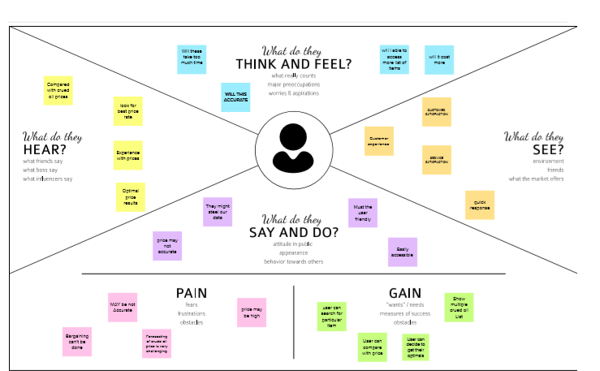

**3.2 IDEATION AND BRAINSTORMING:**

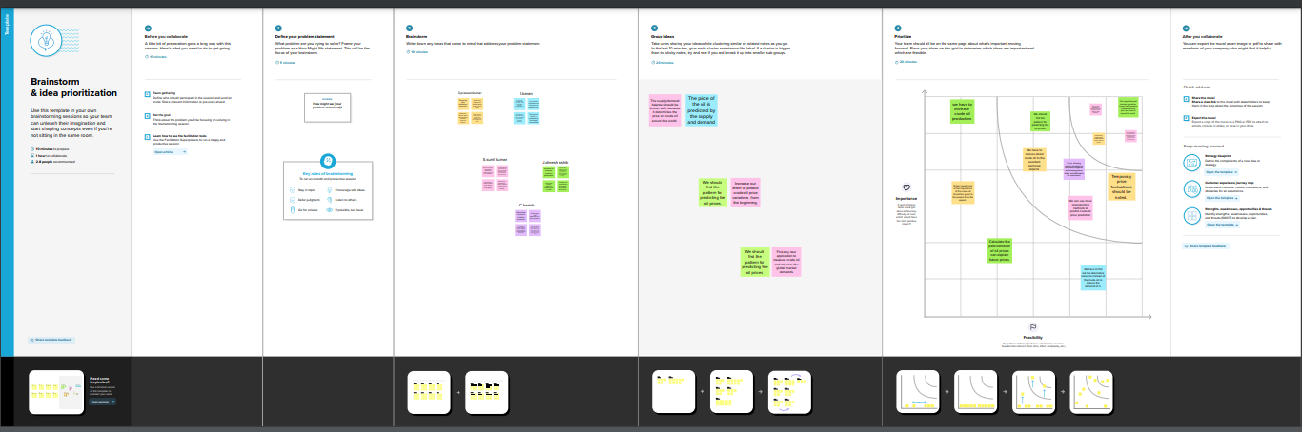

**3.3 PROPOSED SOLUTION:**

|  |  |  |
| --- | --- | --- |
| **S. No.** | **Parameter** | **Description** |
| 1 | Problem  Statement  (Problem to be Solved) | To help the investors, public and private organizations to find a way to predict the crude oil price so that they can understand the oscillations of the crude oil prices and also to help them understand the impact on global economics and minimize the risk associated with the transient nature of crude oil prices. |
| 2 | Idea /  Solution description | The issues identified are overcome in our proposed solution by predicting the price of crude oil by utilizing several Deep Learning Algorithms. The algorithms are implemented in various fields such as the Opening, Closing and the Mean Price of Crude Oil. A Multivariate Analysis Model is planned to be built in the future to visualize how the price of crude oil changes concerning the other commodities. |
| 3 | Novelty / Uniqueness | We divide crude oil price forecasting approaches into three categories: (1) heuristic approaches; (2) econometric models; and (3) machine learning techniques.  Heuristic approaches for oil price prediction include professional and survey forecasts, based on professional knowledge, judgments, opinion and intuition. Econometric models are the most widely used approaches for oil price prediction, which include autoregressive moving average (ARMA) models and vector autoregressive (VAR) models, with possibly different input variables. Machine learning techniques were proposed for oil price prediction, such as artificial neural networks , and support vector machines. |
| 4 | Social Impact  / Customer  Satisfaction | As crude oil is a major source of fuel, predicting its price would provide a clear-cut view of its trend. Governments, Private Enterprises and other institutions can stock it accordingly to prevent scarcity and sudden price rises. If the organizations can anticipate it and take the action accordingly, they would be able to overcome the issues during critical situations. |
| 5 | Business Model  (Revenue Model) | Crude oil price prediction helps for the supply of crude oil is determined by the ability of oil companies to extract reserves from the ground and distribute them around the world. |
| 6 | Scalability of the Solution | To improve the precision of the solution we need to include more factors which are either affecting directly or indirectly the price of the crude oil. |

**3.4 PROBLEM SOLUTION FIT:**

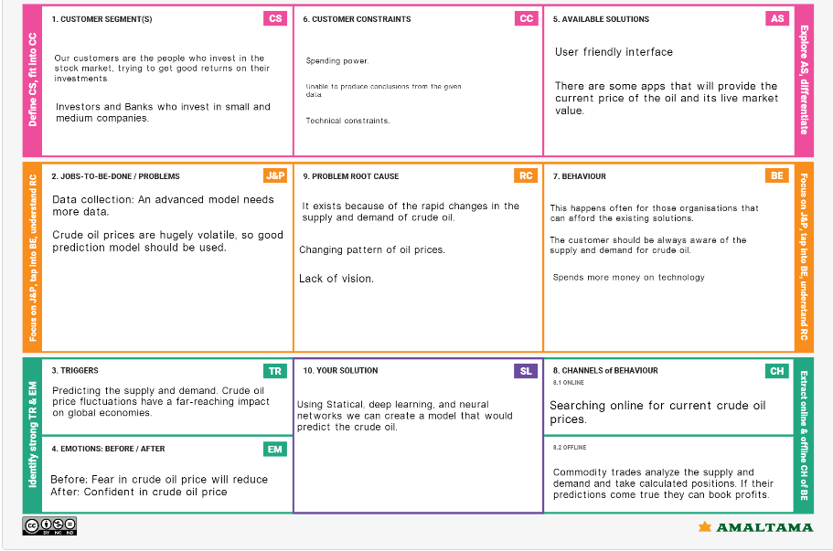

**4 REQUIREMENT ANALYSIS:**

**4.1 FUNCTIONAL REQUIREMENT:**

|  |  |  |
| --- | --- | --- |
| **FRNO.** | **FUNCTIONAL REQUIREMENT** | **SUB REQUIREMENT** |
| FR-1 | User Registration | Registration through Form  Registration through Gmail  Registration through LinkedIn |
| FR-2 | User Confirmation | Confirmation via Email  Confirmation via OTP |
| FR-3 | User Enquiry | Enter the date or range of dates |
| FR-4 | User Visualization | Visualize the trend  Enquire the prices  Analyze the results |
| FR-5 | User Endowment | See the results  Gain Knowledge |
| FR-6 | User Utilization | Use it in your idea  Close the portal |

**4.2 NON-FUNCTIONAL REQUIREMENT:**

|  |  |  |
| --- | --- | --- |
| **FRNO.** | **NON-FUNCTIONAL REQUIREMENT** | **DESCRIPTION** |
| FR-1 | **Usability** | The application interface is easy to use and implement. |
| FR-2 | **Security** | The credentials are secured and the result is encrypted. |
| FR-3 | **Reliability** | The accuracy and reliability quotient is quoted to be high. |
| FR-4 | **Performance** | The performance is uninterrupted and undeterred |
| FR-5 | **Availability** | The data is freely available and the trend can be manually analyzed |
| FR-6 | **Scalability** | The predictions are scalable and reliable. |

**5 PROJECT DESIGN**

**5.1 DATA FLOW DIAGRAM:**

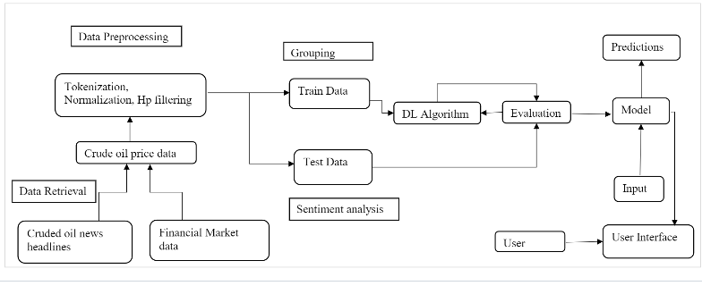

**5.2 SOLUTION AND TECHNICAL ARCHITECTURE:**

**Solution Architecture**

Solution architecture is a complex process- with many sub-processes-that bridges the gap between business problems and technology solution. Its goals are to:

* Find the best tech solution to solve existing business problems.
* Describe the software’s structure, characteristics, behaviour, and other aspects to project stakeholders.
* Define features, development phases, and solution requirements.

Provide specifications according to which the solution is defined, managed, and delivered.

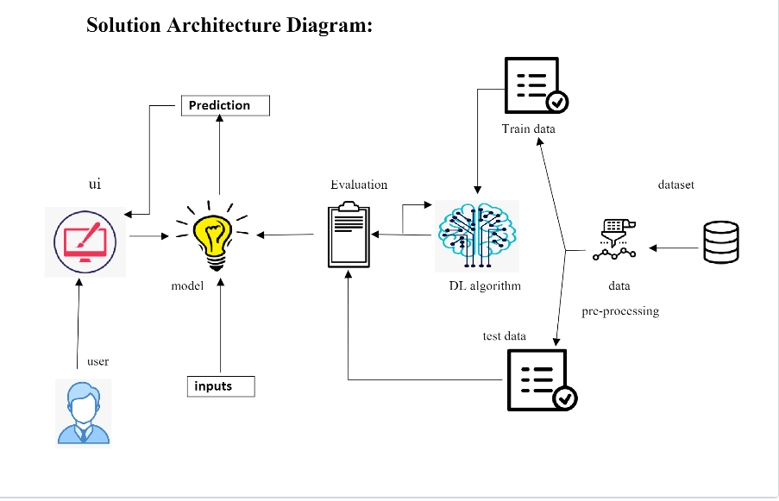

**Context View**

This view gives a high level representation of the system, the different user types and interactions with external entities. It describes the boundaries of the solution.

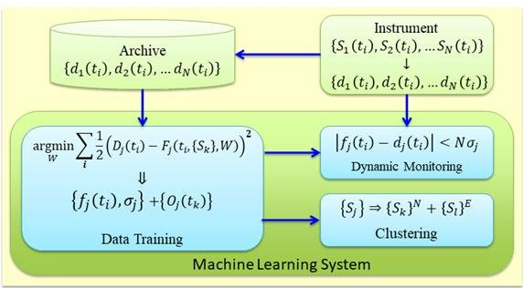

**Project View**

This section shows how key functionality relevant to the solution architecture maps to releases and milestones.

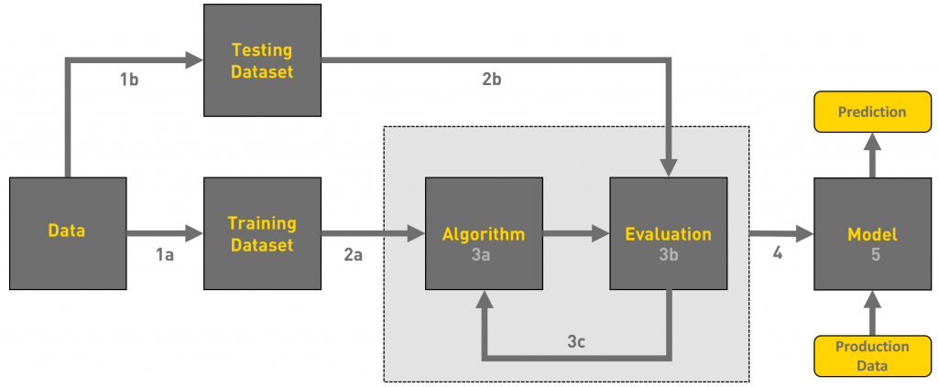

**Functional View**

This section describes the key functional areas of the project. The goal is to provide context around the architecture – all software performs some functionality and the definition of this functional scope is a very important factor to define the architecture.

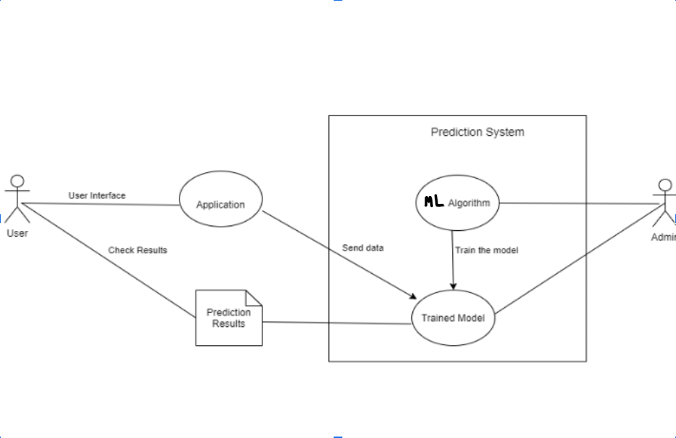

**Process View**

The intent of the process view is to show how the various processing steps within the system fit together to implement the overall functional requirements. This is necessary if the system relies on workflow processes, forked or parallel processing mechanisms. The following processes are significant:

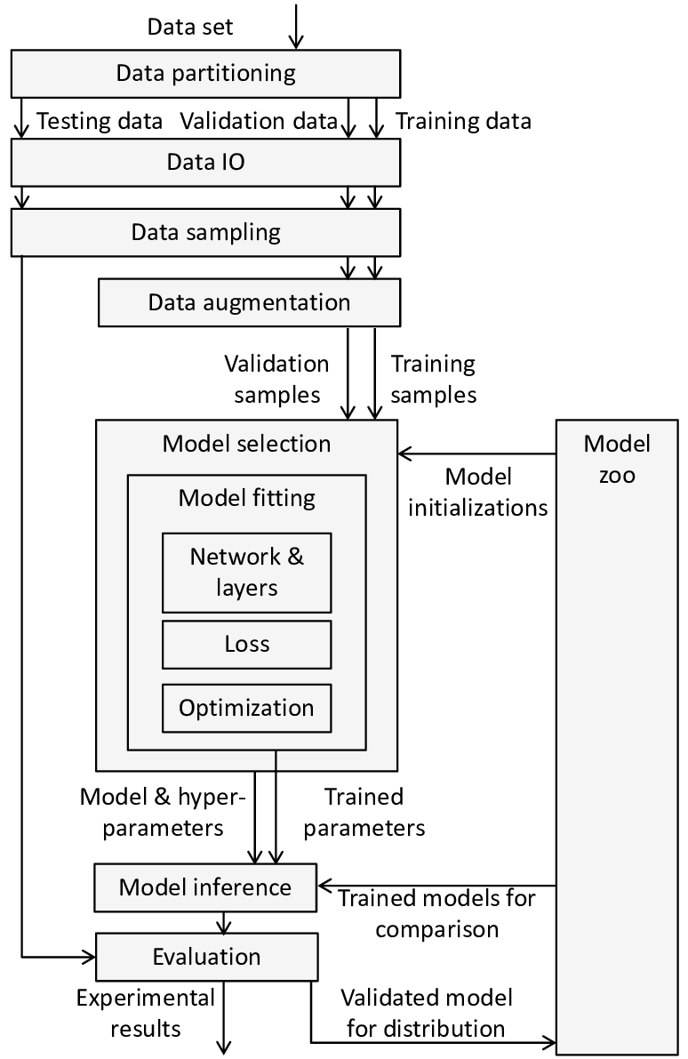

**Non Functional View**

This section describes architecturally significant changes that enable the solution to achieve the agreed non-functional requirements (NFRs). Each change is mapped to the corresponding NFR category, which is based on the ISO/IEC 25010-2011 product quality model.

NFRs are documented and maintained in the Non Functional Requirements Definition and will not be repeated here. In case of duplication, the Non Functional Requirements Definition takes precedence.

Performance Easy tracking of records and updating can be done. All the requirements relating to performance characteristics of the system are specified in the section below. There are two types of requirements.

1.Static Requirements:

These requirements do not impose any constraints on the execution characteristics of the system. They are:

A) Number of Terminals: The software makes use of an underlying database that will reside at the same system, while the front end will be available to the administrative computer.

B) Number of Users: The number of users can be administrator only, but this software can be extended to applications for almost all staff members of the organization.

2. Dynamic Requirements:

These specify constraints on the execution characteristics of the system. They typically include response time and throughout of the system. Since these factors are not applicable to the proposed software, it will suffice if the response tine is high and the transactions are carried out precisely and quickly. Reliability: The software will not be able to connect to the database in the event of the server being down due to a hardware or software failure.

3. Availability:

The software will be available only to administrator of the organization and the product as well as customer details will be recorded by him. He can add customers, update and delete them as well as add new products and manage them.

4. Security:

The security requirements deal with the primary security. The software should be handled only by the administrator and authorized users. Only the administrator has right to create new accounts and generating inventory. Only authorized users can access the system with username and password of administrator

5. Maintainability:

Backups for database are available.

6. Portability:

The Software is a web-based application and is built in Python and Nosql so it is platform independent and is independent of operating system.

**Logical View**

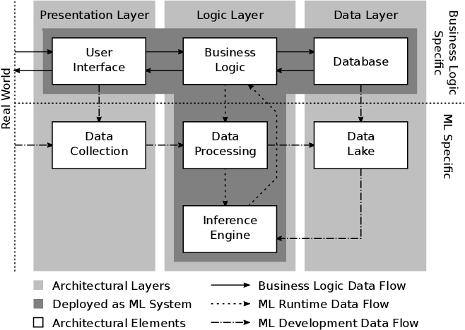

# Interface View

This section describes the interfaces that will be required to the external system integration touch points

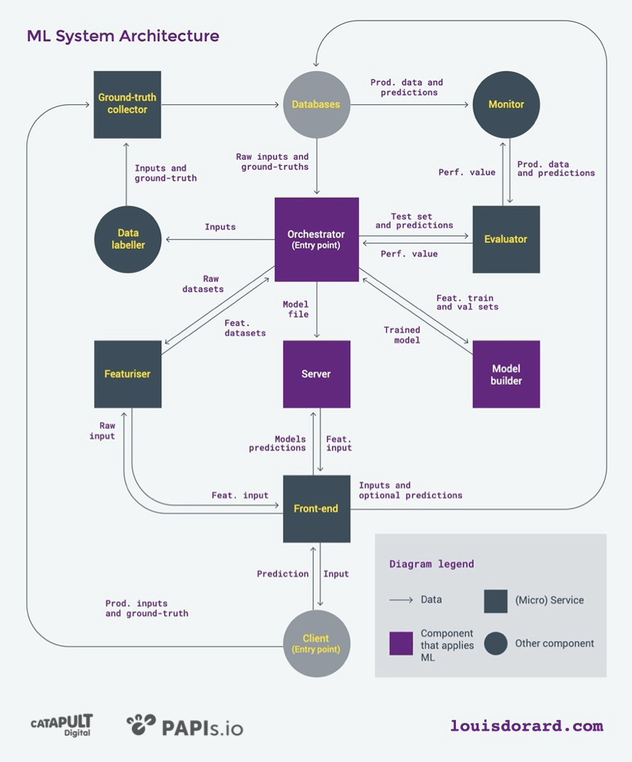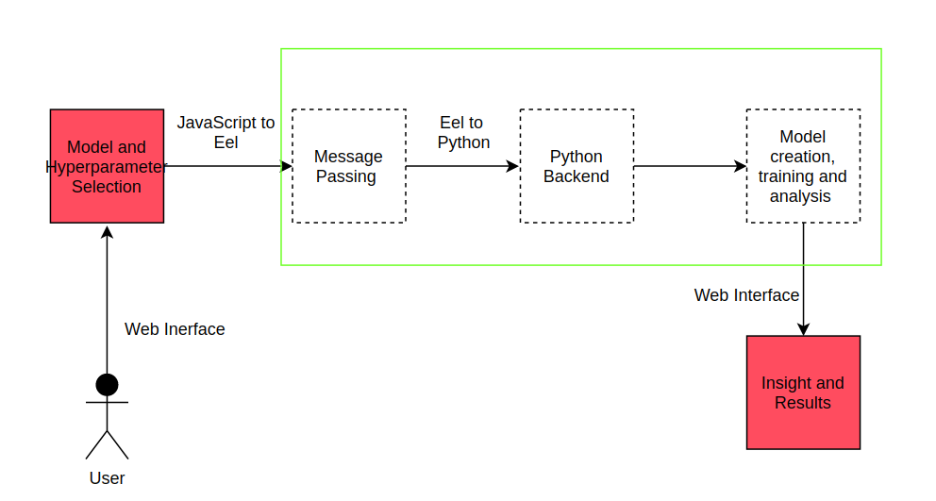

**Deployment View**

This section describes how code will be deployed in test environments and key considerations for the more complex Production go-live deployment.

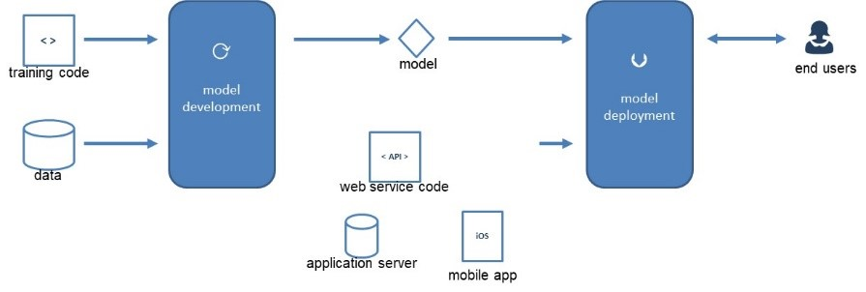

**Operational View**

This section describes how the architecture will support operational processes and activities.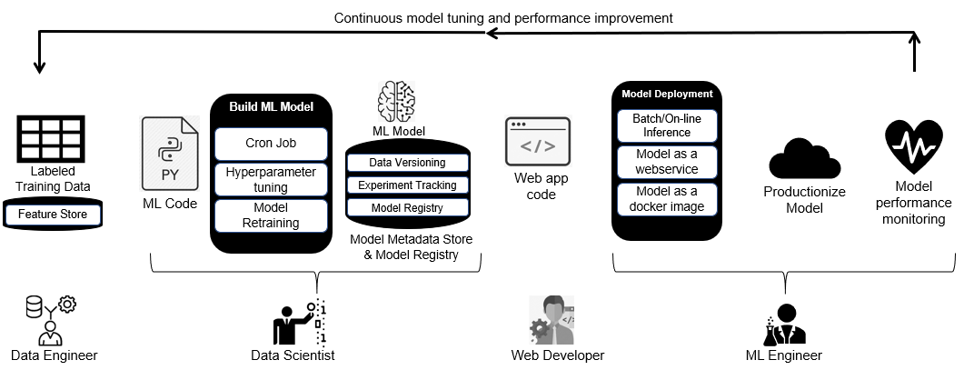

**Security View**

This section describes how the architecture addresses the different security aspects.

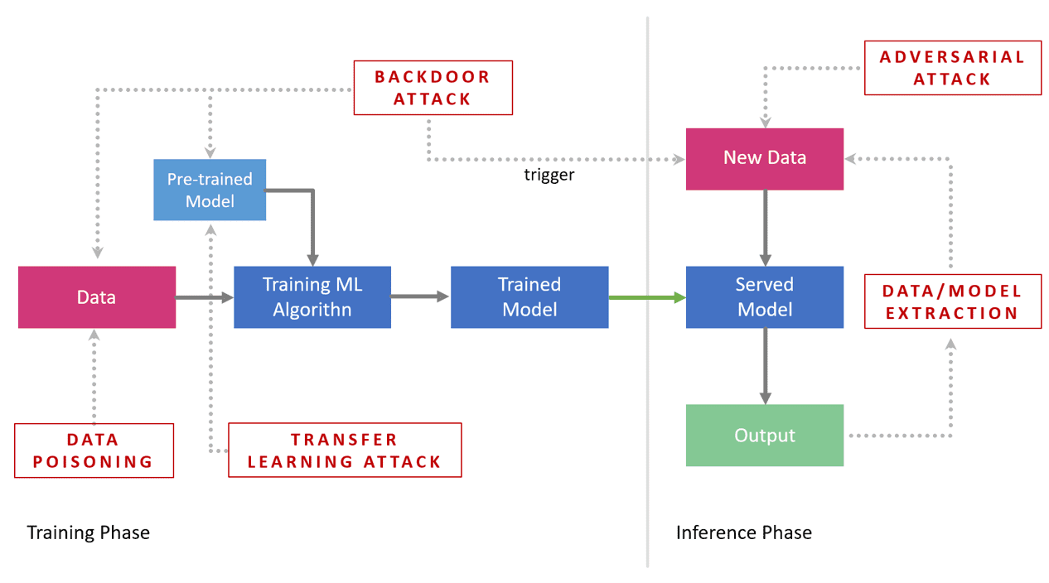

**5.3 USER STORIES**

|  |  |  |  |  |  |  |
| --- | --- | --- | --- | --- | --- | --- |
| **User Type** | **Functional Requirement (Epic)** | **User Story Number** | **User Story / Task** | **Acceptance criteria** | **Priority** | **Release** |
| Customer (Mobile user) | Registration | USN-1 | As a user, I can register for the application by entering my email, password, and confirming my password. | I can access my account / dashboard | High | Sprint-1 |
|  |  | USN-2 | As a user, I will receive confirmation email once I have registered for the application | I can receive confirmation email & click confirm | High | Sprint-1 |
|  |  | USN-3 | As a user, I can register for the application through Facebook | I can register & access the dashboard with Facebook Login | Low | Sprint-2 |
|  |  | USN-4 | As a user, I can register for the application through Gmail |  | Medium | Sprint-1 |
|  | Login | USN-5 | As a user, I can log into the application by entering email & password |  | High | Sprint-1 |
|  | Line\Bar Graph |  | After entering the inputs ,the model will display predictions in Line\Bar Graph Format | I can get the expected prediction in various formats. | High | Sprint-3 |
| Customer (Web user) | Login | USN-1 | As the web user ,I can login simply by using Gmail or Facebook account. | Already created gmail can be used for Login. | Medium | Sprint-2 |
| Customer Care Executive | Support |  | The Customer care service will provide solutions for any FAQ. | Solve the problem by support | Low | Sprint-3 |
| Administrator | News |  | Admin will Provide the recent news of Oil Prices. | Provide the recent oil prices | High | Sprint-4 |

**6 PROJECT PLANNING AND SCHEDULING:**

**6.1 SPRINT PLANNING AND ESTIMATION:**

|  |  |  |  |  |  |  |
| --- | --- | --- | --- | --- | --- | --- |
| **Sprint** | **Functional**  **Requirement**  **(Epic)** | **User story Number** | **User Story/Task** | **Story point** | **Priority** | **Team**  **Members** |
| Sprint-1 | Registration | USN-1 | As a user, I can register for the application by entering my email, password, and confirming my password | 10 | High | MOHANDAS  .V |
| Sprint-2 |  | USN-2 | As a user, I will receive confirmation email once I have registered for the application | 10 | HIGH | PRAVEEN  KUMAR.G |
| Sprint-1 | Login | USN-3 | As a user, I can log into the application by entering email & password | 15 | HIGH | HARISH.C |
| Sprint-2 | Input Necessary Details | USN-4 | As a user, I can give Input Details to Predict Likeliness of crude oil | 15 | High | DHINESH ASIK.J |
| Sprint-2 | Data Pre-processing | USN-5 | Transforming the raw data into suitable format for price prediction. | 15 | High | KARAN.I |
| Sprint-3 | Crude oil price prediction | USN-6 | As a user, I can predict Crude oil using the model | 20 | High | SUNIL KUMAR.S |
| Sprint-3 |  | USN-7 | As a user, I can get accurate prediction of crude oil | 5 | Medium | MOHANDAS.V |
| Sprint-4 | Feedback | USN-8 | As a user, I can give feedback of the application | 20 | High | MOHANDAS.V SUNIL KUMAR.S |

**6.2 SPRINT DELIVERY SCHEDULE:**

|  |  |  |  |  |  |  |
| --- | --- | --- | --- | --- | --- | --- |
| **Sprint** | **Total Story Points** | **Duration** | **Sprint Start Date** | **Sprint End Date (Planned)** | **Story Points Completed** | **Sprint Release Date (Actual)** |
| Sprint-1 | 20 | 6 Days | 24 Oct 2022 | 29 Oct 2022 | 20 | 29 Oct 2022 |
| Sprint-2 | 20 | 6 Days | 31 Oct 2022 | 05 Nov 2022 | 20 | 05 Nov 2022 |
| Sprint-3 | 20 | 6 Days | 07 Nov 2022 | 12 Nov 2022 | 20 | 12 Nov 2022 |
| Sprint-4 | 20 | 6 Days | 14 Nov 2022 | 19 Nov 2022 | 20 | 19 Nov 2022 |

1. ***CODING & SOLUTIONING (Explain the features added in the project along with code)***
   1. *A LSTM Price forecasting machine learning model*
   2. *A User Interface for forecasting based on the past 10 days price*
2. ***TESTING***

*Test Cases*

|  |  |  |  |  |  |  |
| --- | --- | --- | --- | --- | --- | --- |
|  |  |  |  |  |  |  |
|  |  |  |  |  |  |  |
|  |  |  |  |  |  |  |
|  |  |  |  |  |  |  |
|  |  |  |  |  |  |  |
|  |  |  |  |  |  |  |
|  |  |  |  |  |  |  |
|  |  |  |  |  |  |  |
|  |  |  |  |  |  |  |
|  |  |  |  |  |  |  |

**7.CODING & SOLUTION (Explain the features added in the project along with code)**

**7.1 FEATURES**

|  |  |  |
| --- | --- | --- |
| FR No. | Feature | Description |
| FR-1 | Crude oil Price Graph | Showing the price of crude oil for respective dates in a graph with dates in x axis and crude oil prices on y axis |
| FR-2 | Current Price Prediction | Showing the last predicted price of the crude oil |
| FR-3 | Prediction based on user provided values | When user provided with the three days prices of the crude oil the application will give predicted price for the next day |

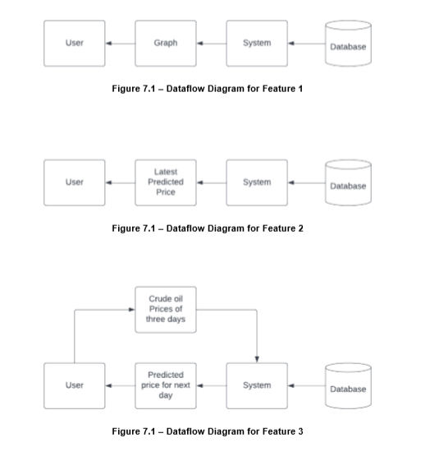

**8. TESTING**

8.1 Test Cases The test cases are window of closing prices, where the window size is 3. The test cases are sent to the model and the prediction is compared with the original closing price. The loss metric is used to analyze the performance of the model. Figure 8.1 shows the result after the testing. The blue line in the bottom shows the true closing prices. The orange lines denote the prediction using the training data. The green line denotes the prediction based on testing data.

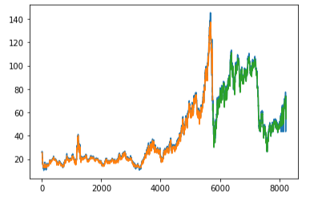

***9.RESULTS***

* 1. *Performance Metrics – RMSE – 2.78*

***10.ADVANTAGES & DISADVANTAGES***

*The model is able to forecasting the price accurately based on the past 10 days data.*

*But whenever the commodity is affected by external factors which are caused naturally then the predictions are bad. This cannot be predicted by machine learning model*

***11.CONCLUSION***

*Therefore the ml was deployed as a web app and the user interface is handy for stakeholders who do not have much knowledge in programming. The predicted value is displayed in the user interface.*

***12.FUTURE SCOPE***

*The machine learning model can be improved by converting it from univariate to multi variate model for better understanding the price value. This can result in a great boost in the prediction accuracy.*

**13 APPENDIX**

**13.1 Source Code**

**App. Py:**

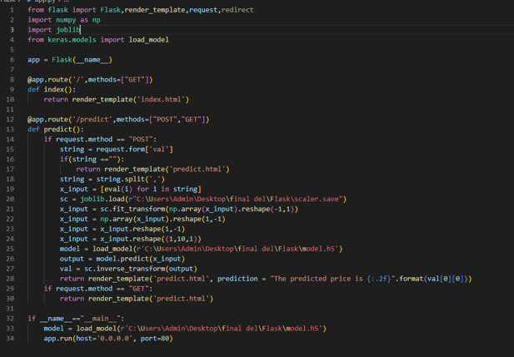

**from flask import Flask,render_template,request,redirect**

**import numpy as np**

**import joblib**

**from keras.models import load_model**

**app = Flask(__name__)**

**@app.route('/',methods=["GET"])**

**def index():**

**return render_template('index.html')**

**@app.route('/predict',methods=["POST","GET"])**

**def predict():**

**if request.method == "POST":**

**string = request.form['val']**

**if(string ==""):**

**return render_template('predict.html')**

**string = string.split(',')**

**x_input = [eval(i) for i in string]**

**sc = joblib.load(r"C:\Users\Admin\Desktop\Final Deliverables\Flask\scaler.save")**

**x_input = sc.fit_transform(np.array(x_input).reshape(-1,1))**

**x_input = np.array(x_input).reshape(1,-1)**

**x_input = x_input.reshape(1,-1)**

**x_input = x_input.reshape((1,10,1))**

**model = load_model(r'C:\Users\Admin\Desktop\Final Deliverables\Flask\model.h5')**

**output = model.predict(x_input)**

**val = sc.inverse_transform(output)**

**return render_template('predict.html', prediction = "The predicted price is {:.2f}".format(val[0][0]))**

**if request.method == "GET":**

**return render_template('predict.html')**

**if __name__=="__main__":**

**model = load_model(r'C:\Users\Admin\Desktop\Final Deliverables\Flask\model.h5')**

**app.run(host='0.0.0.0', port=80)**

**Index.HTML.txt:**

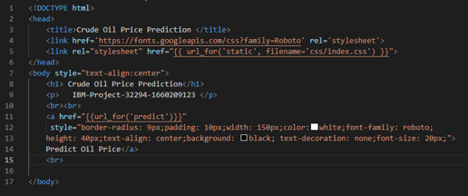

**<!DOCTYPE html>**

**<head>**

**<title>Crude Oil Price Prediction </title>**

**<link href='https://fonts.googleapis.com/css?family=Roboto' rel='stylesheet'>**

**<link rel="stylesheet" href="{{ url_for('static', filename='css/index.css') }}">**

**</head>**

**<body style="text-align:center">**

**<h1> Crude Oil Price Prediction</h1>**

**<p> IBM-Project-32294-1660209123 </p>**

**<br><br>**

**<a href="{{url_for('predict')}}"**

**style="border-radius: 9px;padding: 10px;width: 150px;color:white;font-family: roboto;**

**height: 40px;text-align: center;background: black; text-decoration: none;font-size: 20px;">**

**Predict Oil Price</a>**

**<br>**

**</body>**

**Predict.HTML.txt:**

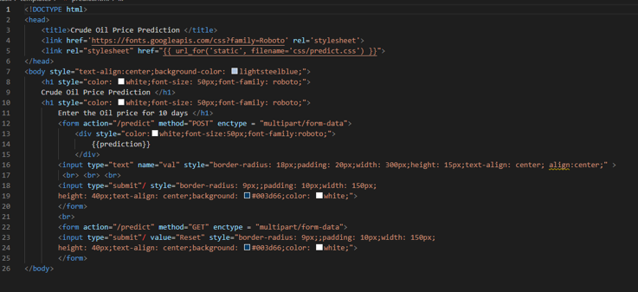

**<!DOCTYPE html>**

**<head>**

**<title>Crude Oil Price Prediction </title>**

**<link href='https://fonts.googleapis.com/css?family=Roboto' rel='stylesheet'>**

**<link rel="stylesheet" href="{{ url_for('static', filename='css/predict.css') }}">**

**</head>**

**<body style="text-align:center;background-color: lightsteelblue;">**

**<h1 style="color: white;font-size: 50px;font-family: roboto;">**

**Crude Oil Price Prediction </h1>**

**<h1 style="color: white;font-size: 50px;font-family: roboto;">**

**Enter the Oil price for 10 days </h1>**

**<form action="/predict" method="POST" enctype = "multipart/form-data">**

**<div style="color:white;font-size:50px;font-family:roboto;">**

**{{prediction}}**

**</div>**

**<input type="text" name="val" style="border-radius: 18px;padding: 20px;width: 300px;height: 15px;text-align: center; align:center;" >**

**<br> <br> <br>**

**<input type="submit"/ style="border-radius: 9px;;padding: 10px;width: 150px;**

**height: 40px;text-align: center;background: #003d66;color: white;">**

**</form>**

**<br>**

**<form action="/predict" method="GET" enctype = "multipart/form-data">**

**<input type="submit"/ value="Reset" style="border-radius: 9px;;padding: 10px;width: 150px;**

**height: 40px;text-align: center;background: #003d66;color: white;">**

**</form>**

**</body>**

**13.2. GitHub & Project Demo Link**

**GitHub link:**

[**https://github.com/IBM-EPBL/IBM-Project-32294-1660209123**](https://github.com/IBM-EPBL/IBM-Project-32294-1660209123)

**Project Demo Link:**

[**https://drive.google.com/drive/folders/1-R1Oj57Mf5WzhUBdnRlkljKzKwzds_i7?usp=sharing**](https://drive.google.com/drive/folders/1-R1Oj57Mf5WzhUBdnRlkljKzKwzds_i7?usp=sharing)